**COLLECTION ASSIGNMENT**

1.Given a TreeMap <Long, Contact> which has phone numbers for keys and contact objects for values.

Write solutions to

a.Fetch all the keys and print them,

b.Fetch all the values and print them

c.print all key-value pairs.

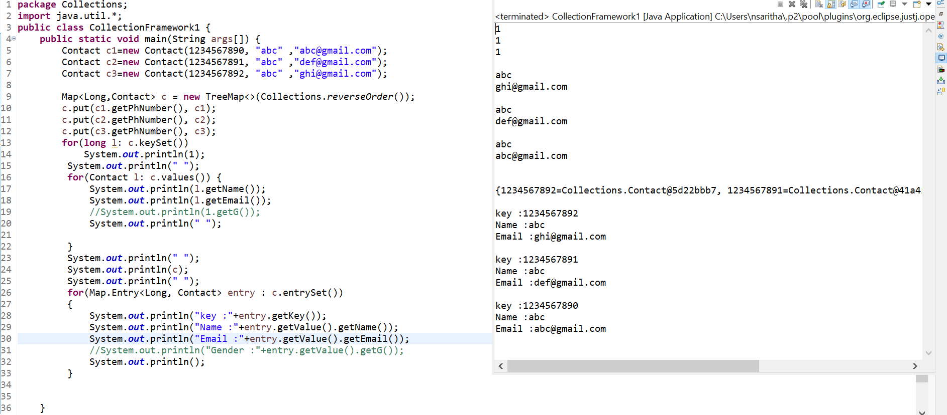

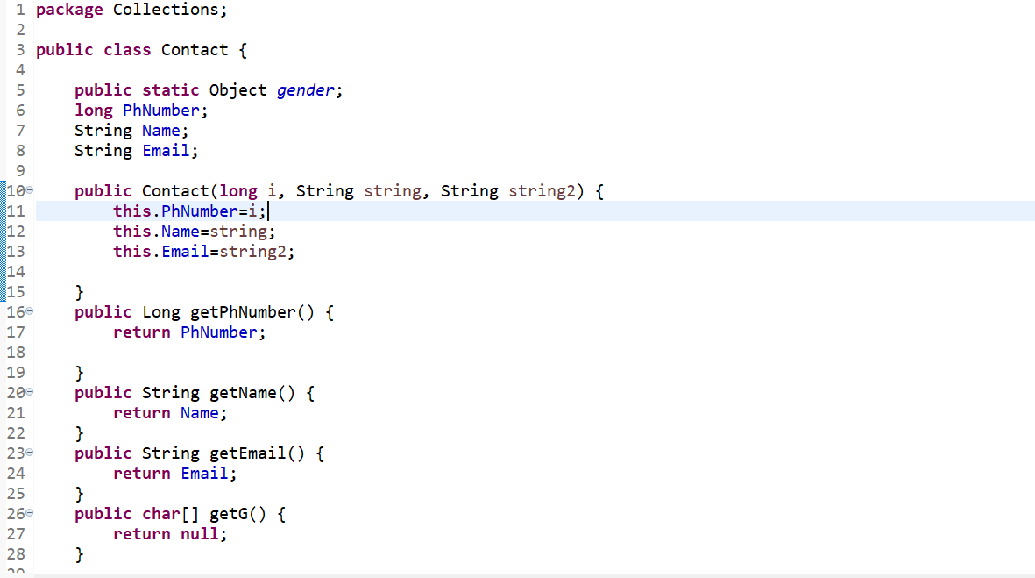

2.Write an application to store 10 unique product objects. In case there is an attempt to add a duplicate product, It should be silently rejected.

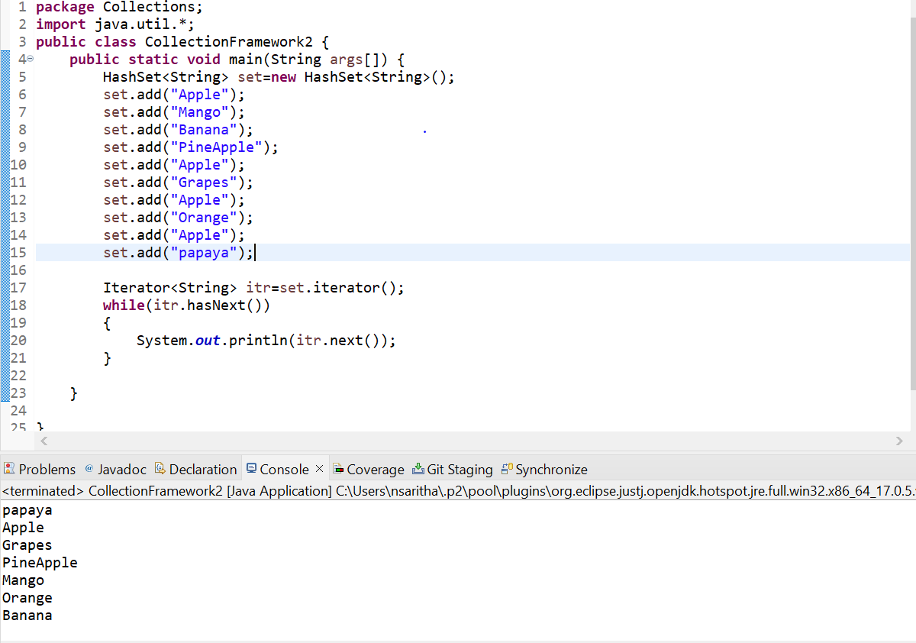

3.Strore at least 10 Employee objects in TreeSet<Employee>. When the application runs the user should be asked to select one of the options upon which you will print the employee details in a sorted manner.

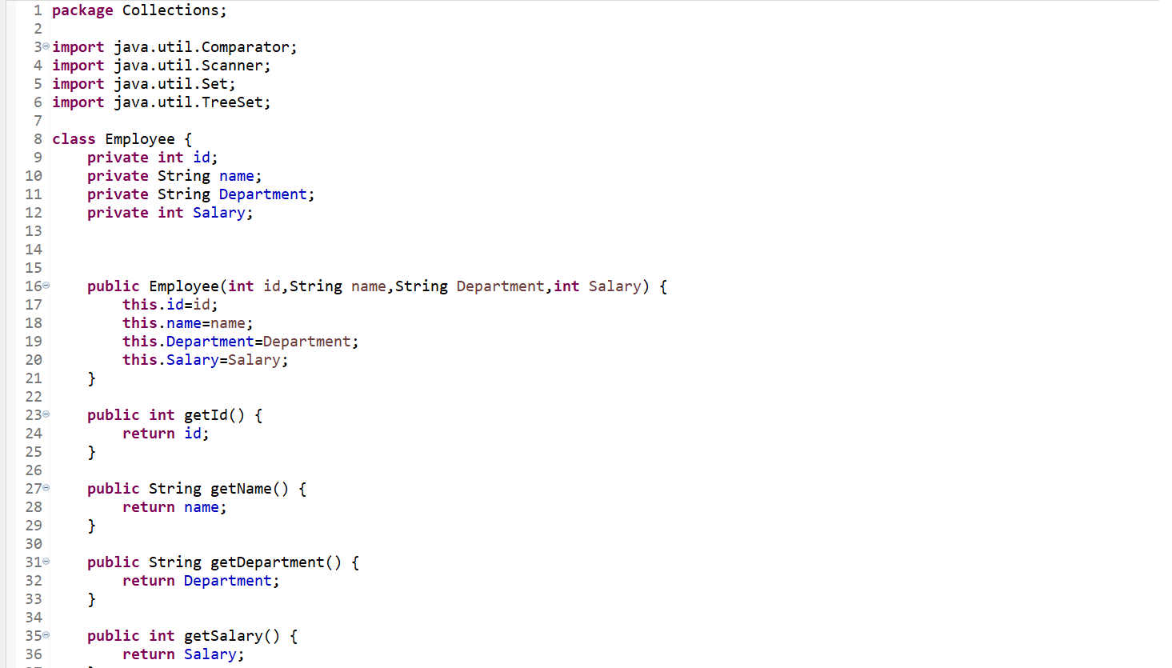

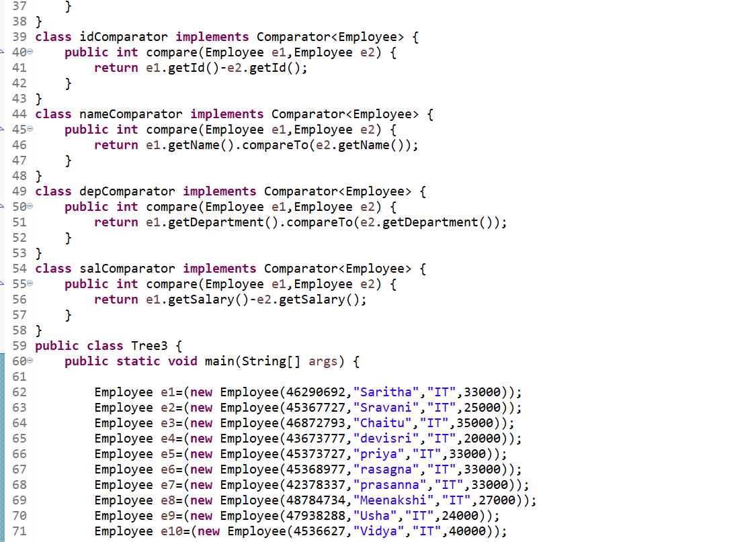

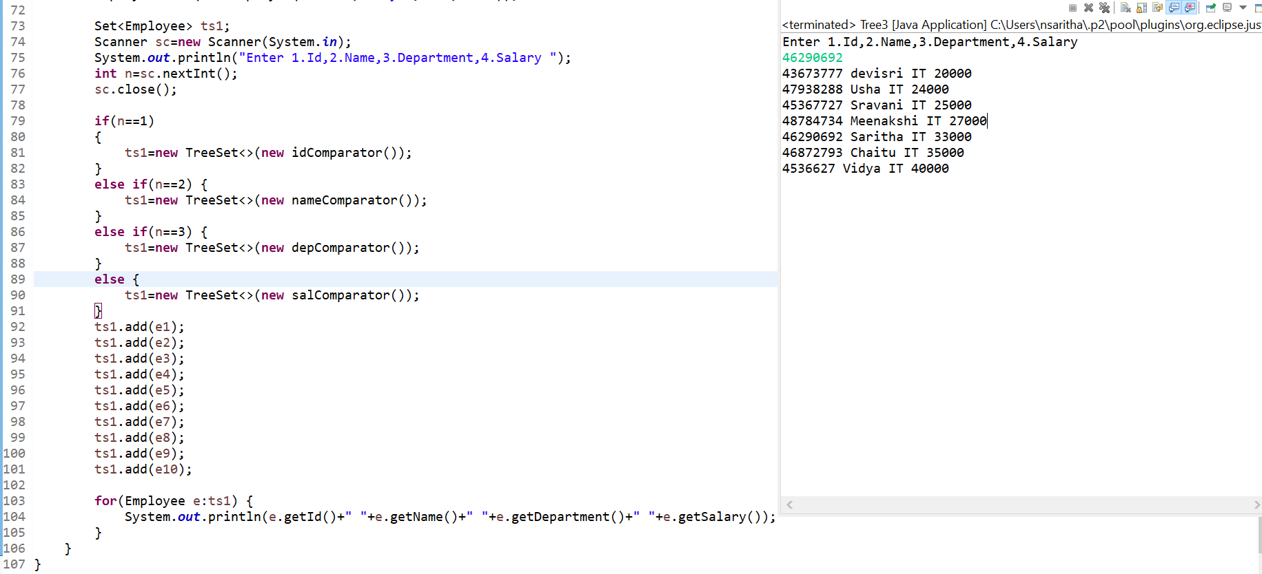

4.Given a LinkedList of objects representing date of birth’s, print the date’s along with the message. Your date of Birth is DD-MM-YYYY, and it a leap year.

